even Semester (2022)



**BINUS UNIVERSITY**

**BINUS INTERNATIONAL**

**Assignment Cover Letter**

**(individual Work)**

|  |  |  |  |  |  |  |  |  |  |  |
| --- | --- | --- | --- | --- | --- | --- | --- | --- | --- | --- |
|  | | | | |  | |  | |  | |
| **Student Information**: **Surname** | | | | |  | | **Given Names**  Jotika | | **Student ID Number**  **2201796655** | |
| 1. | | **Adhisthana** | Yuwono | |  | |
|  |  |  | |
| **Course Code** | **: COMP6510** |  |  | |  | | **Course Name** | | **: Programming Languange** | |
| **Class** | **: L2AC** |  |  | |  | | **Name of Lecturer(s)** | | : 1. Minaldi Loeis  2. Jude Joseph Lamug Martinez | |
|  |  |  |  | |  | |  | |  | |
| **Major** | **: CS** |  |  | |  | |  | |  | |
| **Title of Assignment** | : Stock data program | |  |  | |  | |  | |  | |
| **Type of Assignment**    **Submission Pattern** | **: Final Project** |  |  | |  | |  | |  | |
| **Due Date** | **: 02/07/2019** |  |  | |  | | **Submission Date** | | **: 02/07/2019** | |

The assignment should meet the below requirements.

1. Assignment (hard copy) is required to be submitted on clean paper, and (soft copy) as per lecturer’s instructions.
2. Soft copy assignment also requires the signed (hardcopy) submission of this form, which automatically validates the softcopy submission.
3. The above information is complete and legible.
4. Compiled pages are firmly stapled.
5. Assignment has been copied (soft copy and hard copy) for each student ahead of the submission.

# Plagiarism/Cheating

BiNus International seriously regards all forms of plagiarism, cheating and collusion as academic offenses which may result in severe penalties, including loss/drop of marks, course/class discontinuity and other possible penalties executed by the university. Please refer to the related course syllabus for further information.

# Declaration of Originality

By signing this assignment, I understand, accept and consent to BiNus International terms and policy on plagiarism. Herewith I declare that the work contained in this assignment is my own work and has not been submitted for the use of assessment in another course or class, except where this has been notified and accepted in advance.

Signature of Student: (Name of Student)

1. Jotika Adhisthana

Table of Contents

1. Cover
2. Table of Contents
3. Introduction
4. Solution Design
5. Discussion
6. Implementation
7. How it works
8. Result Evidence
9. References

**Introduction**

Concept:

The program is designed to put items to a storage and make it easier to count and to manage all of the items that is put or taken form the storage.

Problem:

People are usually lazy about writing the number of items that come out of the storage if its too massive or too little so I created this program to make it easier to input the data and update it.

**Solution Design**

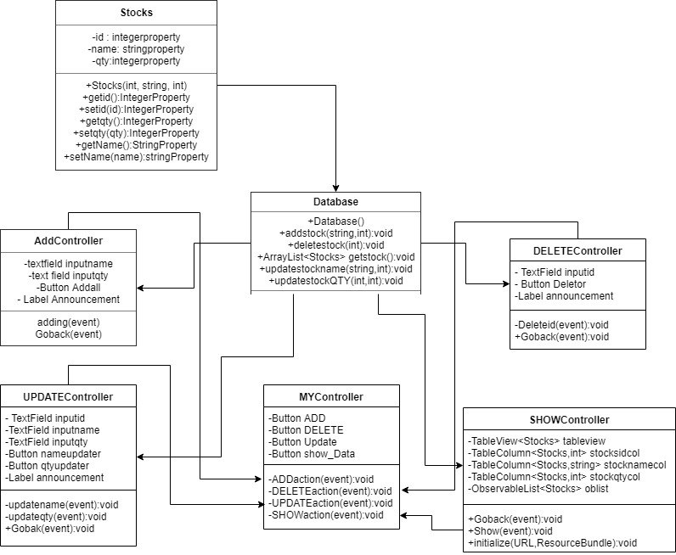

**Discussion**

1. Implementation:

Javafx was used to develop the GUI.

Java.sql was used to access and process the data stored in MySQL database.

Java.util.ArrayList was used to temporarily store the data received from the database to use it.

Java.io.IOException was used to check for the errors that occur

java.util.ResourceBundle was used for data that is associated with browsers

1. How the Program Works:

* In the main menu, there will be 4 buttons and it will do a different type of things.
* If you press the button that says the add stock it will go to another menu where you can add any amount of data into the database.
* If you press the button that says delete stock it will go to another menu where you can delete any amount of data by inputing the id they had.
* If you press the button that says “update stock” it will go to another menu where you can update any data you want by input the id and the new data.
* If you press the button that says “show stock” it will go to another menu. There you can press the show button to get the data from the database and shows it.
* In every menu of the buttons there will be a go back button it returns the user to the main menu.

Result Evidence

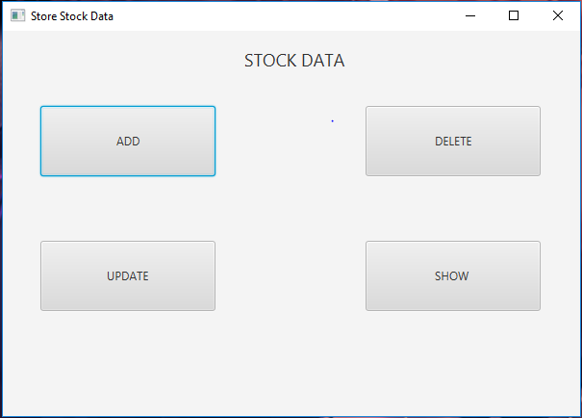

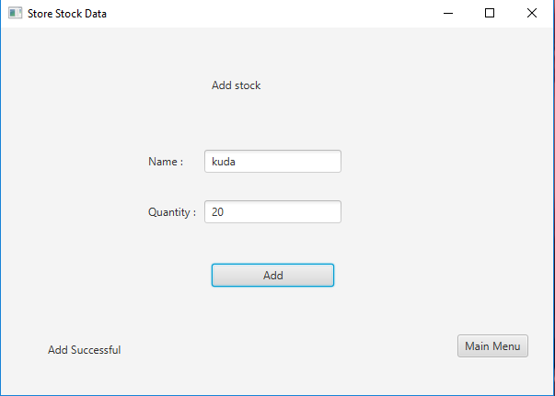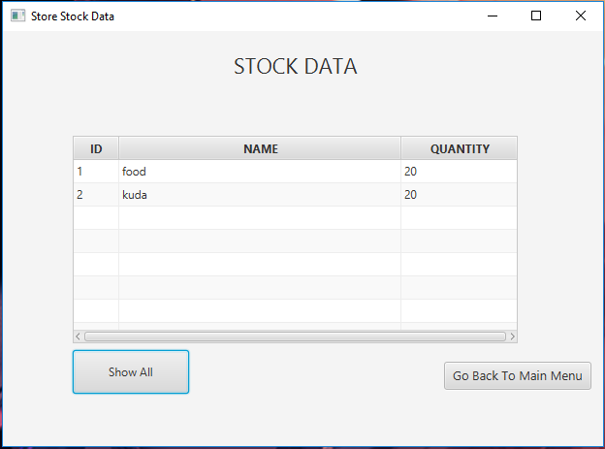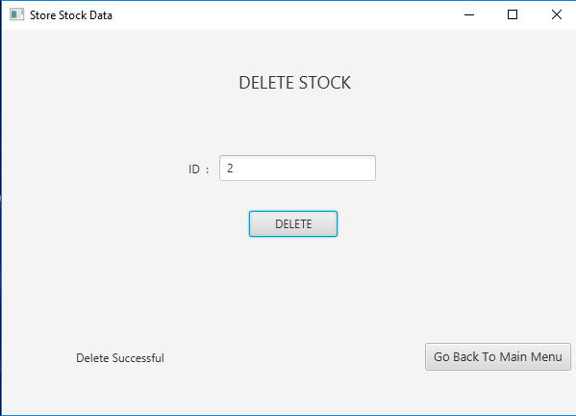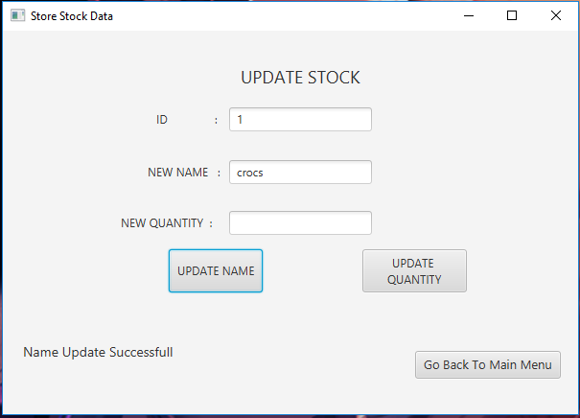

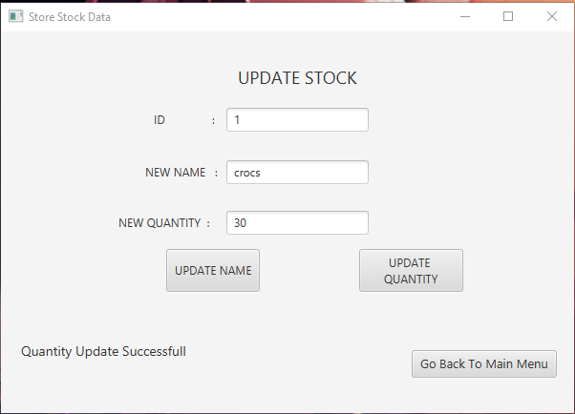

**REFERENCES**

https://www.youtube.com/watch?v=XCgcQTQCfJQ

https://www.youtube.com/watch?v=Bufe5s9OuUE